29th May 2021

First rider off 10.01am

Promoted for and on behalf of CTT under their rules & regulations.
This is a Northumberland & Durham Cycling Association BAR Event.

Event Secretary: Justine Norman
30 Robsons Way
NE65 0GA
Tel: 07725071072

Timekeepers: Sharon Dyson
Peter Schultz

Event HQ: Embleton Village Hall

Covid 19 – please read carefully

- Please do not come to the event if you feel unwell or have any covid symptoms or if you or a member of your household are awaiting the results of a covid test.
- Please use the provided hand sanitizer prior to signing in/ signing out
- Riders must provide their own pen to sign in/ sign out- no pens will be provided . Please also bring your own safety pins if required
- Please wear a mask if entering the Hall or the toilets
- Riders should consider carrying a mobile phone and tool kit with them- please make note of the organizer mobile number to contact in case of a mechanical
- Riders must not gather on or near the course or at the HQ
- Please maintain 2m social distancing from other riders at all times
- On completion of the race competitors must not loiter at the finish or HQ and must sign out and leave immediately
- Please report to the start line no more than 5 minutes before your start time and adhere to social distancing prior to starting
- Riders will need to self start with one foot on the ground, no track stands
- Riders must have a working rear light. No light = no ride
- No Drafting

Event instructions

- Embleton Village Hall (post code NE66 3UP) is the HQ and will be open from 8:30am to sign on and collect numbers. – please sign off at the HQ afterwards.
- If you fail to sign out you will be recorded as a DNF on the results sheet.
- Sign in and sign out must be completed by the rider and no one else.
- Numbers are disposable- please take your numbers/rubbish home afterwards.
- Numbers should be clearly visible and placement adhere to CTT regulations
- Toilets will be available to use in the Hall.
- Embleton is a small village so please be respectful while parking/warming up in the village. Please do not use turbo trainers in residential areas. There is a small amount of parking at the Hall so parking will need to be around the village but please be respectful to residents when parking. Please leave the village as soon as you can having finished the race and signed out.
- For those competing on Road Bikes please also complete the separate road bike sheet so that your time can be pulled out from final set of results. When competing on road bikes, the rider must not use tri bars, wheels deeper than 60 mm, Aerohelmets with built in visors or trip socks. Skin suits are permitted-please refer to the N&DCA website for further details
- Junior riders must bring or email the organiser a completed parental consent form
- All riders must adhere to CTT regulations at all times

Course M13:
Start just north of Embleton on the B1339 opposite the lay-by.
Proceed north on the B1339 to turn left on to the B1340 in the direction of Christon Bank. Proceed to the junction with the B1347 at Christon Bank.**** Turn left to continue south on the B1340 to the junction with the minor road near Hocketwell.
Bear left on to minor road and continue south to minor road on left near Littlehoughton. Turn left on to minor road and proceed east to the T-junction with the B1339. Turn left on to the B1339 and proceed north towards Embleton. Finish at the lay-by PRIOR to Embleton village. Please shout your number as you pass the finishing timekeeper.

****Please be aware that there are 2 traffic calming measures in Christon Bank- one as you ride into Christon Bank ( you must give way to traffic ) and one after you have turned left in Christon Bank ( you have priority) . Please treat these traffic calming measures with respect . Marshals will be in the vicinity and any riding deemed to be unsafe will result in disqualification

Safety Update:
Note that there have been two accidents in 3 years on this course, both on part of the course highlighted above in red. This is a fast downhill section with a couple of tight corners that may have gravel at the very edges. If you have the opportunity prior to the race, please check this section of the course. Please ride with care and adapt speed to the road conditions.

Please do not warm up around the start area or on the course

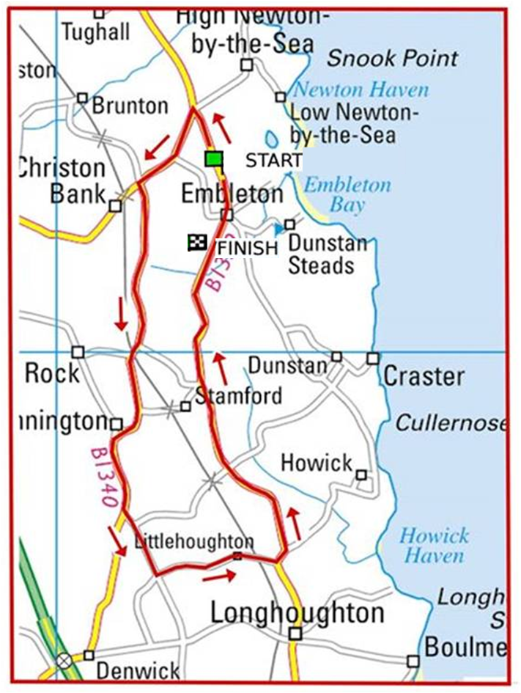

Safety Notes:
- Vehicles of competitors / officials / marshals / helpers to be parked safely and without hindrance to other road users.
- Take extra care at road junctions.
- No U-turns to be made in the vicinity of the timekeeper.
- No pre-race warming up on course.
- Care by riders - do not cross the white line on left hand turns. Crossing the white lines may lead to a DQ
- Care by riders – extra care in built up areas.
- No dismounting by riders in finishing area.
- Extra care in Christon bank re traffic calming- as previously mentioned

In the interests of your own safety, Cycling Time Trials and the event promoters strongly advise you to wear a HARD SHELL HELMET that meets an internationally accepted safety standard.
All competitors under the age of 18 years and/or juniors must wear a Protective Hard Shell Helmet.
A working rear light in a position visible to following road users is essential

T
If you find that you can no longer ride, please contact
Justine Norman
Justine.norman99@gmail.com

